show databases;
create database IF NOT exists newdatabase32;
show databases;
use newdatabase32;

CREATE TABLE student16 (
stdid int4,
stdname VARCHAR(20),
dob DATE,
doj DATE,
fee int4,
gender CHAR
);
DESC student16;

INSERT INTO student16 (stdid, stdname, dob, doj, fee, gender)
VALUES (1, 'SHAREEF', '2001-01-10', '2001-10-05', 10000, 'M');

INSERT INTO student16 (stdid, stdname, dob, doj, fee, gender)
VALUES (2, 'NADEEM', '2019-11-03', '2001-10-26', 11000, 'M');

ALTER TABLE student16 ADD phone_no NUMERIC(10);

ALTER TABLE student16 RENAME COLUMN phone_no TO student_no;

ALTER TABLE student16 RENAME to STUDENT_INFO5;

RENAME TABLE STUDENT_INFO5 TO student_data5;

ALTER TABLE student_data5 DROP COLUMN gender;

SELECT * FROM student_data5;

ALTER TABLE student_data5 DROP COLUMN gender;

DELETE FROM student_data5

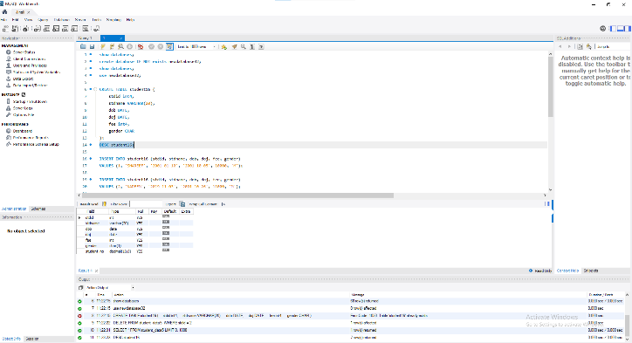
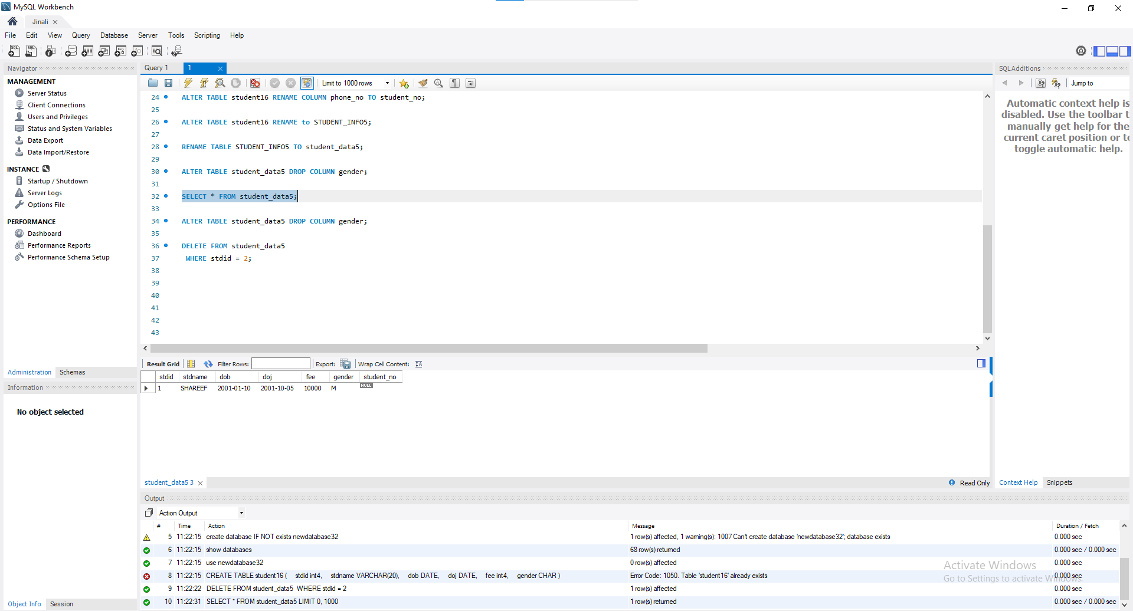
WHERE stdid = 2;

